Wizard Forms
Chapter
3

Forms are used as another way of looking at data in Tables or Queries. They can also be used for entering data that is then stored in the underlying Table. Forms can be based on just one table or query or multiple tables and queries.

A simple form can be used to enter data.
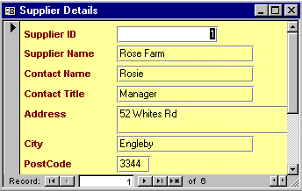

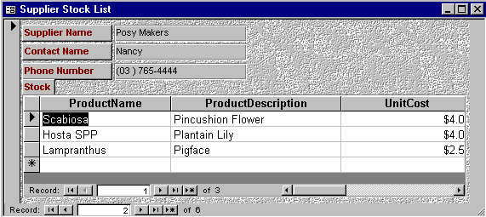

Relationships between tables present opportunities for how the data can be displayed. A sub-form can be utilised so that data can be put into categories. For example the main form may be one supplier at a time. The sub form within the main form may list all the stock supplied by that particular supplier.

Objectives

In this chapter you will use a Form Wizard to

- Create a Form based on a Table
- Create a Form based on a Query
- Create a Form with a Subform
- Create a Form with a Linked Subform

- Open the database file Ch3 Wizard Forms

Forms are much quicker and easier to create using the Form Wizard.
- Click on the Forms tab

New

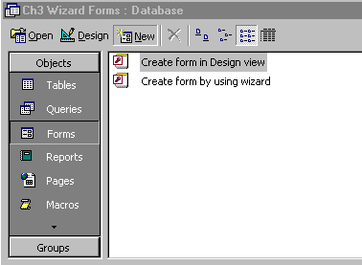
Forms tab

- Click on New

The New Form dialog box appears.

- Click on Form Wizard
Form Wizard

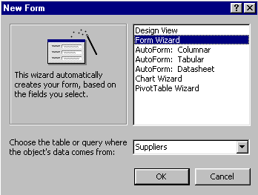
- Click on Suppliers in the Choose which table….

- Click on OK

Choose which table

The Form Wizard will be activated.

- Turn the page to work through the Wizard steps

When the Form Wizard starts the first step is to determine the fields that will be included on the form. This form is for data entry of all the details of a Supplier so all the fields will be used.

- Click on the Select All Fields button to put all the fields in the “Available Fields” into the “Selected Fields” list as shown below
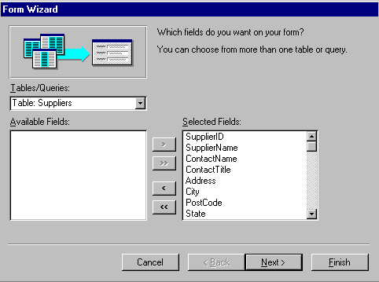
Select all fields button

- Click on Next
- The next step is for a Layout of the fields – leave as is and click on Next
- Choose the Style of Standard for the form and click on Next
- Enter Supplier Details as the name of the form and click on Finish

The form will be created and appear on the screen with the first record displayed. The Navigation buttons can be used to move through the records.
Close
Navigation buttons
- Close the
form

Practice Exercise 3.1

- Repeat the process using the Form Wizard to create simple forms for data entry for the Customers and Stock tables.

The forms will look something like this depending on the choices you made.
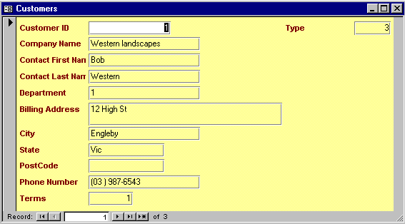
The Customers Form.

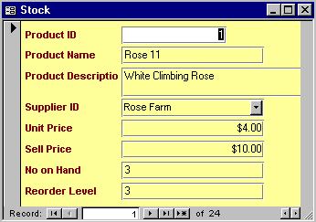
The Stock Form.

- Close the open forms

Basing Forms on Queries

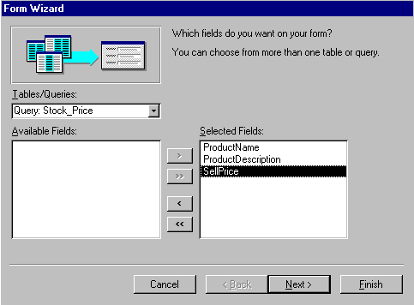
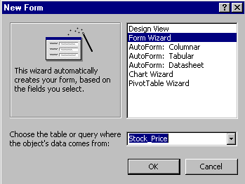
Forms can also be based on Queries. For example a Form could be used to display stock price details.

- Start a new Form using the Form Wizard based on the query Stock_Price
(This query uses only the fields Product Name, Product Description and Sell price and prompts for the Product name – then it will display the Name, a Description and a Sell price)

- Select all fields to appear on the form then a Style and Layout
- Click on Finish to create the form

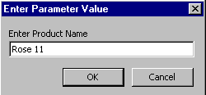
A Form based on a Query will behave as the query behaves when opened. If the query is a Parameter Query then the form will also display the Prompts on opening.

- Type Rose 11 in the prompt box and click on OK to display the form
Close
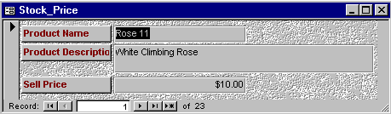
- Close the form

Forms with Subforms

When a database consists of related tables more opportunities arise with Forms and displaying data. A Subform is totally dependent on the contents of the main Form. In the example shown here, a list of Stock is displayed in the Subform dependant on the Supplier displayed in the main Form.

To create the form shown above do the following…..
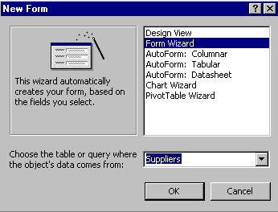
- Click on the Form tab if necessary
- Click on New ➢ Form Wizard
- Click on the Choose the table or query…….
- Click on Suppliers and OK

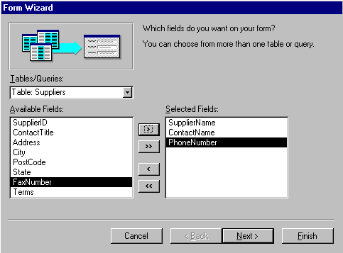
- Click on SupplierName and the Select Field button then ContactName and Select Field button as shown below, then once again for the PhoneNumber field
Selected Fields

- DON’T CLICK ON NEXT YET!!!! Turn the page for the next step
- Click in the Tables/Queries box AGAIN and select the Stock table as shown below

- Put in the following fields in the Selected Fields box using the Select fields button

ProductName

ProductDescription
UnitCost
SellPrice

The Selected Fields should now contain fields from both the Supplier and Stock tables. Using fields from more than one table enables us to create a subform provided the two tables have a relationship.
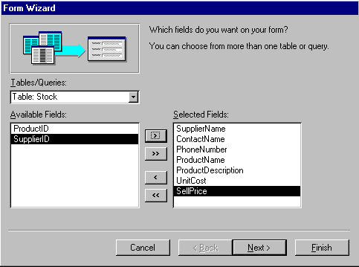

Change this to Table:Stock to select fields to display from this table

- Click on Next

- Click on by Suppliers so the Supplier is the main form and the Stock is listed for each supplier in the subform.
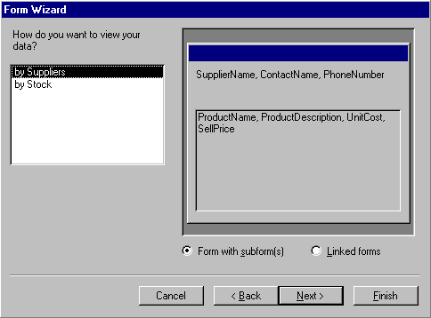
By Supplier
Note: There is a choice of Form with Subform or Linked forms – check that Form with Subform is selected
- Click on Next

- Click on Datasheet for Layout then Next

- Click on a Style for the forms then Next

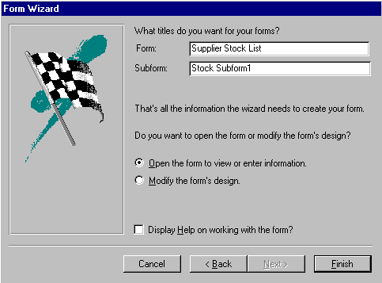
- Give the main Form the name Supplier Stock List

- Click on Finish

The Form and Subform appear. The contents of the Subform are totally dependent on the record selected in the Main form. So in this example, the Supplier is Posy Makers so all Stock items supplied by Posy Makers appear in the subform.
Main Form navigation buttons
Subform navigation buttons
Main Form
Subform

There are two sets of navigation buttons, one for the main Form and one for the Subform. The Subform will often have a scroll bar.

Forms with Linked Subforms

Forms can also be created which contain links to other forms. The link appears in the Main form as a button that will display the subform when clicked.
- Click on the Forms tab
- Click on New
- Click on Form Wizard
- Click on the Suppliers table and OK
- Put SupplierName and ContactName and PhoneNumber in the Selected Fields box

- DON’T CLICK ON NEXT YET!!!!

- Click in the Tables/Queries box AGAIN and select the Stock table as shown below

- Put in the following fields in the Selected Fields box using the Select fields button

ProductName

ProductDescription
UnitCost
SellPrice

The Selected Fields should now contain fields from both the Supplier and Stock tables.

- Click on Next

- Click on by Suppliers so Suppliers is the main form and the Stock items are listed for each Supplier.
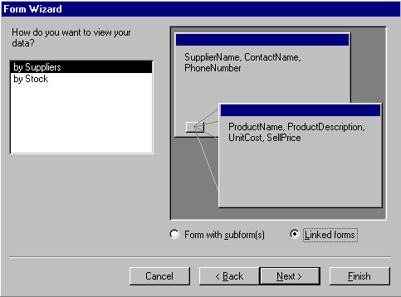
- Click on Linked Forms

- Click on Next

Linked Forms

- Pick out a style then click on Next

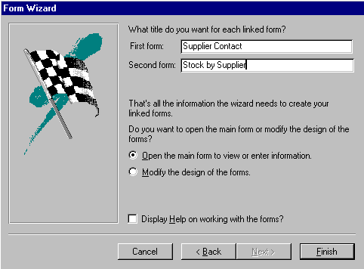
- Enter the following names for the Form and Subform as shown below

- Click on Finish

The form will be created with a button to display the Stock items associated with each supplier as shown on the following page.

Note: The subform can be resized
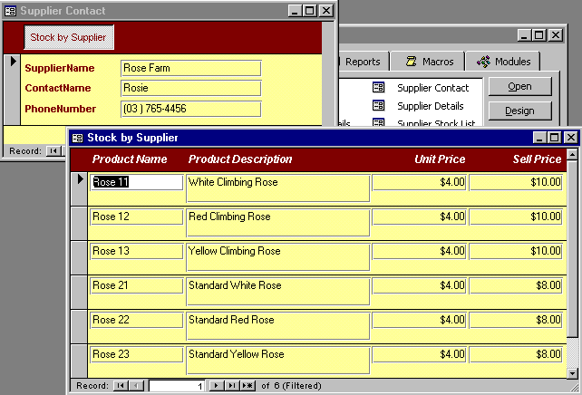
Stock by Suppliers
- Click on the Stock by Suppliers button to display the subform as shown above

The Subform will be displayed, the contents dependent on the record displayed in the Main form. You can resize the subform so it appears as shown above.

- Click on the Close Window button to close the Subform window

- Back at the main form click on the Next Record button to display the next Supplier then click on the Stock by Supplier button to view the Subform

In the next chapter you will learn how to create forms from scratch. You will then be able to use those skills to modify forms you create with the Form Wizard.

